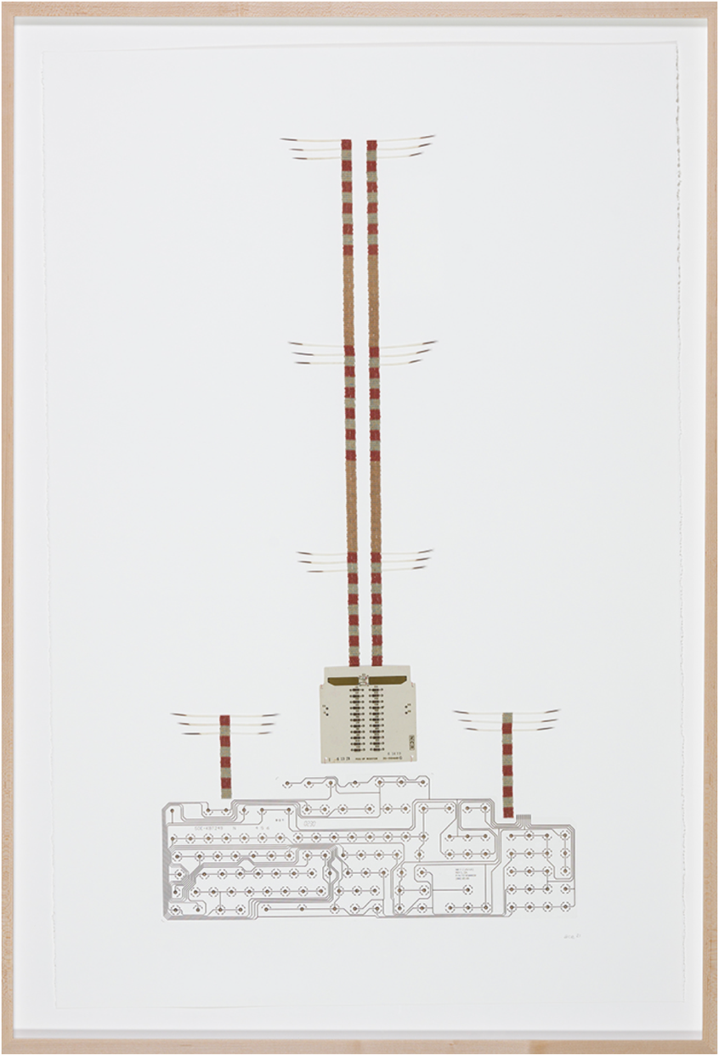

Flight of the Mgizwak (Eagles) Automata
vintage circuit-board, beads, porcupine quills, acetate computer keyboard template on paper
signed and dated 2021. 101.6 x 67.3 cm

PROVENANCE
Collection of the Artist
The Mgizwak are sacred animals for the Anishinaabeg, the most powerful of birds of flight. Their feathers are used for ceremonial items such as fans, staffs and headdresses, as well as presented as honorary gifts or offerings, as they are imbued with spiritual meaning and strong healing medicine. Due to their potency, protocols are put into place. Eagles also represent the channel between humans and the Great Spirit (Gchi Manidoo), carrying prayers to the sky world.
In Flight of the Mgizwak (Eagles) Automata, the wings of these majestic birds are suggested by the porcupine quills the artist has sewn onto the paper. Gesturing upwards, they are simultaneously in motion yet anchored, visually tethered to columns constructed of beaded blocks of copper, silver and gold, the conductive elements for electrical current. The columns echo the apparent vertical motion of the stacked electronic resistors on the white circuit board, where two gold plates, resembling the outstretched wings of an eagle, are etched. Together, the quill and beadwork also reference the architecture of hydroelectric poles. In Anishinaabemowin, the word for bead is manidoominens meaning “spirit berries,” that transmit power and healing. Ace’s inclusion of the beadwork is a subtle simile for the flow of electrons as well as spiritual energy.
Below the symmetrically placed columns is an acetate computer keyboard template, its edge variable and undulating. Space has been left between where the columns end and the circuity lines begin, an interstitial gap that interrupts the connection between them. On the template, gold circles indicate the placement for numerical, alphabetical and directional keys - the top row, the probable location of the F-keys, the preset functions that perform the operating system (OS) commands. Whereas the rising wings symbolize communication with a mythological or higher power, the poles and keyboard denote electronic or digital communication.
The work is part of Ace’s ongoing Automata series which looks at the parallels between communication technology (electronic and digital) and mythology, or as Ace has termed it, the “mythotronic.” With both, the transmission of information must follow a prescribed set of coded rules or protocols in order to produce the desired, and predicted, output or outcome. If an eagle feather falls to the ground during a ceremony or dance, a retrieval ritual is required to lift it up. By performing the correct cultural protocol, the desired result, spiritual balance, is achieved.
These themes of communication and balance are ones Ace often addresses in his work. He considers systems and how the breaks within them, be it the fracturing of the spiritual cohesion of a culture or a disconnection between electrical components, create dysfunction. The abrupt event of colonization - the impact of denominational and state-run residential schools, loss of language and traditional knowledge - is such a fracture. Although elements in Ace’s work are often “metaphors for cultural loss and assimilation,” he suggests that a break “doesn’t preclude that a system cannot be repaired.” Whether utilizing an F-key to initiate an OS function or performing a ritual to convey a message to the spirit realm, if a connection is made, then balance is maintained.
As in Waawaaskesh Dodem (Deer Clan) Automata, Ace includes a vintage circuit board for what it contains, a pictographic image of a deer. While sourcing the electronic ephemera, Ace noticed “abstracted animal forms” embedded in the board’s schematic, here the outstretched gold wings of the eagle and the two trailing rows of vertically spaced resistors, alluding to its ascension. The composition and title of Flight of the Mgizwak (Eagles) Automata reiterate what the schematic reveals. For Ace, the “hardware that drives the electronic age” also contains within it “abstracted pictographic imagery” that recalls Anishinaabe petroglyphs. With this inclusion of e-waste Ace links to earlier forms of communication, closing the gap between past and present. The visual citation is strategic, an assertion of cultural continuance, and a reconnected line.
Essay courtesy of Leah Snyder of The L. Project. Snyder writes about culture, technology and contemporary art, and is a regular contributor to the National Gallery of Canada's Gallery magazine and other Canadian art publications.

